Ti-Juana Perry Week 9 Survival Statistic

In this chapter, we learned that “there is good evidence that more than half, rather than one-fifth, of new small firms survive for eight or more years”.

1. Can you find other evidence to support this?

According to the Small Business Administration Office of Advocacy, about 10 – 12 percent of firms with employees open each year and about 10 – 12 percent close. The Office of Advocacy also states, “about half of all new establishments survive five years or more and about one-third survive 10 years or more.

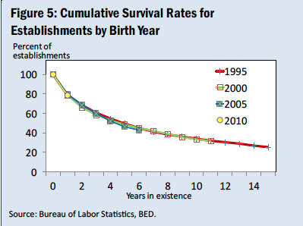

2. What’s the average survival statistic for restaurants?

According to the National Restaurant Association, the survival statistic for restaurants has been on the increase since 1970. From $42.8 billion in 1970 to $709.2 in 2015.

Source: National Restaurant Association, Restaurant Trends Survey, 2014

3. What is the average survival statistic for the business area in your business plan?

Source: Employment Projections program, U.S. Bureau of Labor Statistic

